St Clement’s Catholic Primary School- Science
Topic: Living Things and their Habitats | Year: 4 |  |  | Term: Autumn
What should I already know? |  | Vocabulary
Animals can be grouped into vertebrates (and then further into fish, reptiles, amphibians, birds and mammals) and invertebrates  - Animals can be grouped into carnivores, herbivores and omnivores  - The names of some common wild and garden plants and deciduous and evergreen trees.  - Examples of habitats (including microhabitats) and the animals and plants that can be found there.  - Living things depend on each other to survive.  - How food chains and food webs work.  - How land use has changed over time and the effects this has on the environment (e.g. urban development) |  | Organism | An individual living thing, such as a plant, an animal, or bacteria.
 |  | Classifying | To put into groups according to things that are similar.
 |  | Unique | Being the only one of its type.
 |  | Vertebrate | Having a backbone.
 |  | Invertebrate | Without a backbone.
 |  | Mammal | Any animal that has hair and feeds its babies with milk from the mother.
 |  | Habitat | The natural environment of an animal or plant.
 |  | Ecosystem | A community of living things, together with their environment.
 |  | Food chain | A series of living beings in which each serves as food for the next.
 |  | Energy | The ability to have force or power or to do work.
 |  | Producer | A living thing that makes its own food.
 |  | Consumer | A living thing that cannot make its own food and so received its energy through consuming (eating) other plants or animals.
What will I know by the end of the unit? |  | Diagrams
- All living things, which can also be called organisms, have to do certain things to stay alive. These are the life processes:  Movement – moving, can be fast and obvious or slow and over time  Respiration – releasing energy from food  Sensitivity – responding to their environment  Growth – getting bigger and older  Reproduction – producing offspring  Excretion – getting rid of waste  Nutrition – taking in food  - Living things can be grouped according to different criteria (where they live, what type of organism they are, what features they have). For example, a camel can belong in a group of vertebrates, a group of animals that live in the desert, and a group of animals that have four legs.  - A classification key is a tool that is used to group living things to help us identify them.  - Habitats can change throughout the year and this can have an effect on the plants and animals that live there. Humans can have positive and negative effects on the environment: positive effects: nature reserves, ecological parks negative effects: litter, urban development  CHANGING ENVIRONMENTS  - NATURAL CHANGES – different seasons can change habitats. As the weather changes so can the plant life of the habitat. Look at the area around you; do you notice different plants and possible different animals at different times of the year?  - HUMAN CHANGES – How humans live and what they do can impact habitats both negatively and positively.  Negative ways:  - Deforestation - cutting down trees for a range of reasons  - Littering – dropping rubbish or leaving large objects lying in the environment  - Pollution – introducing harmful substances into the environment.  Positive ways:  - Protecting endangered species via conservation projects  - Cleaning bodies of water  - Recycling |  | 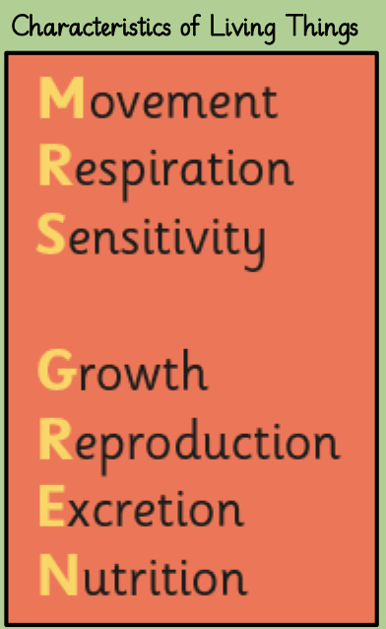  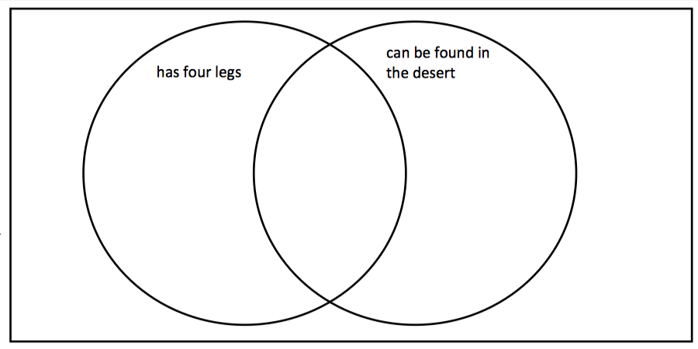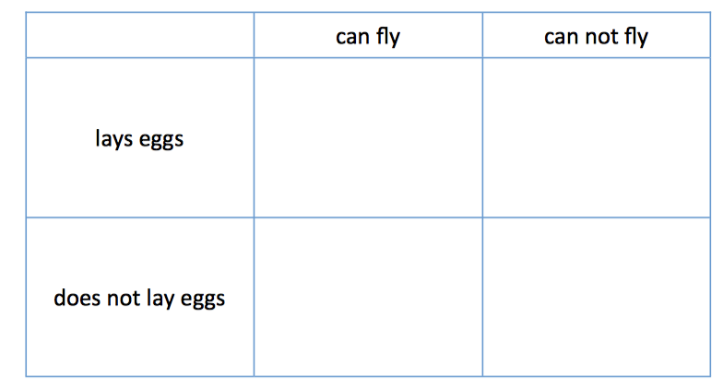  Carroll Diagram  Venn Diagram  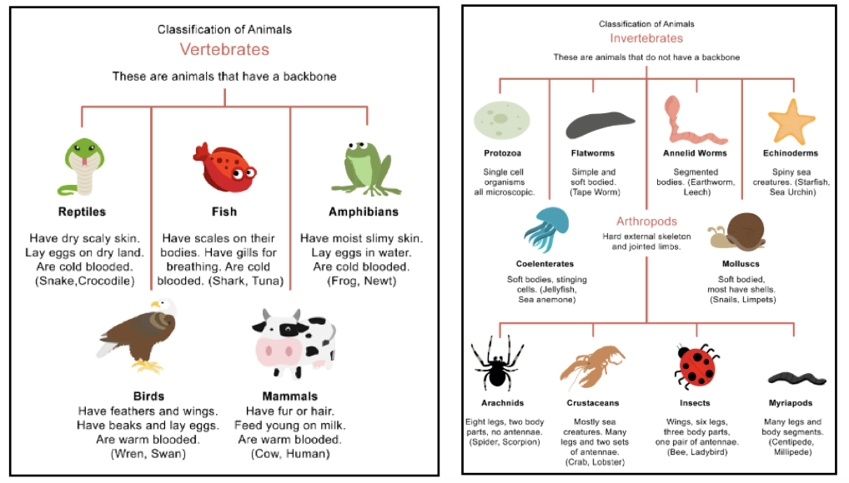
Key facts |  | Famous scientist(s)
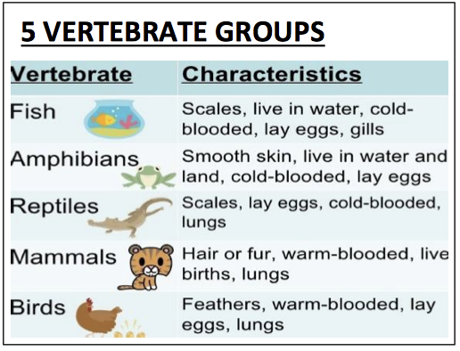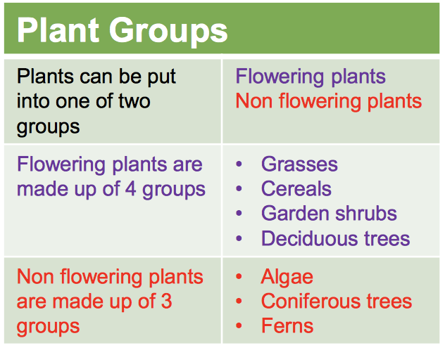 |  | 